NGUYEN VAN TROI PRIMARY SCHOOL  NAME: …………………………………  CLASS: 3… | BÀI KIỂM TRA HỌC KÌ II  MÔN: TIẾNG ANH - LỚP 3  NĂM HỌC 2020 – 2021  Thời gian làm bài: 40 phút.

 | Marks | Listening |  |  |  | Reading |  | Writing |  |  | Speaking | Total
 |  | Q.1 | Q.2 | Q.3 | Q.4 | Q.1 | Q.2 |  | Q.1 | Q.2
 | Comments

PART I: LISTENING (4 marks).

Question 1: Listen and number. There is one example. (1 mark)

 | 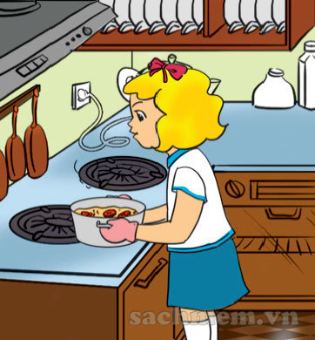 |  | 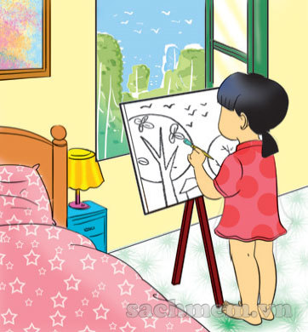 | 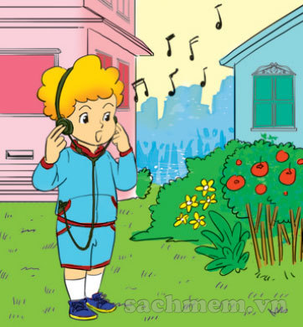
 |  | 0
A. | B. | C. | D. | E.

Question 2. Listen and draw the line. There is one example. (1 mark)

A  1  0 | B | C  2 | D  3 | E  4

Question 3: Listen and tick ().There is one example (1 mark).

0. A. | B.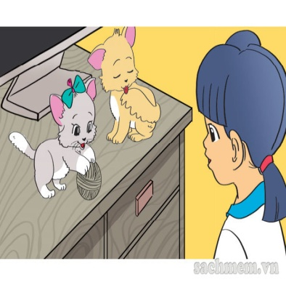
1. A.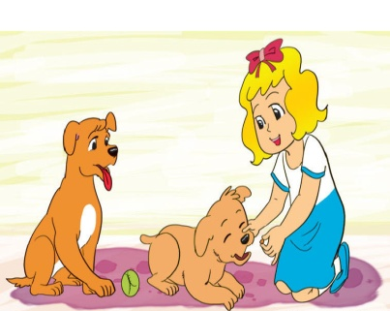 | B. 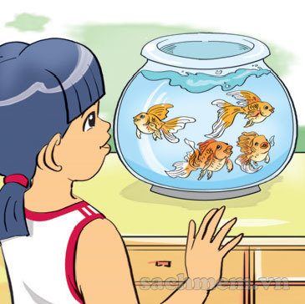
2. A. | B. 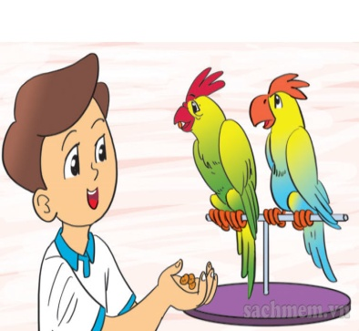
3. A.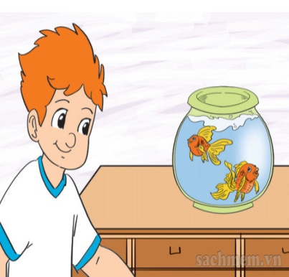 | B.
4. A.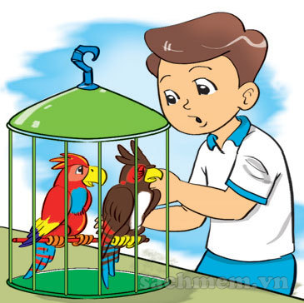 | B. 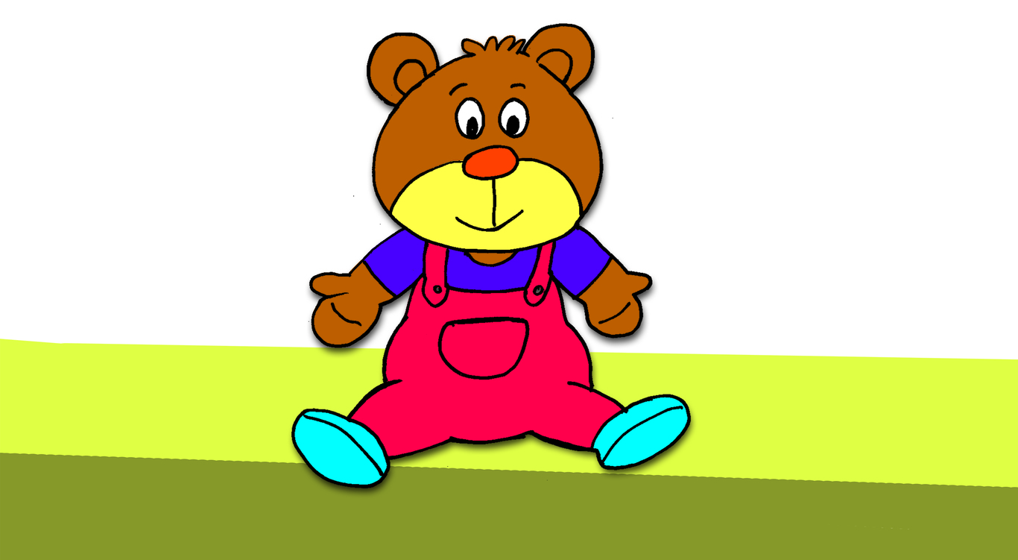
Question 4: Listen and complete. There is one example (1 mark).
Mai: What’s (0) that?
Linda: It’s my (1) __________. Do you have a robot?
Mai: No, I (2) __________. Do you have a (3) _____________ bear?
Linda : (4) _____, I do.

PART II: READING (2 marks)

Question 1. Read and write. There is an example (1mark)
Hi! My name is Nam. I have a lot of pets. This is my cat. It is on the bed. And that is my dog. It is there, under the table. I also have two parrots and a rabbit. They are all in the garden.
1. Nam has a lot of (0) pets

2. He has a cat. It is on the (1) ________.

3. He has a dog. It is (2) __________ the table.

4. He has two (3) __________ and a rabbit. They are in the (4) __________.

Question 2: Look and read. Put a tick ( ) or a cross () in the box. There are
two examples. (1 mark)
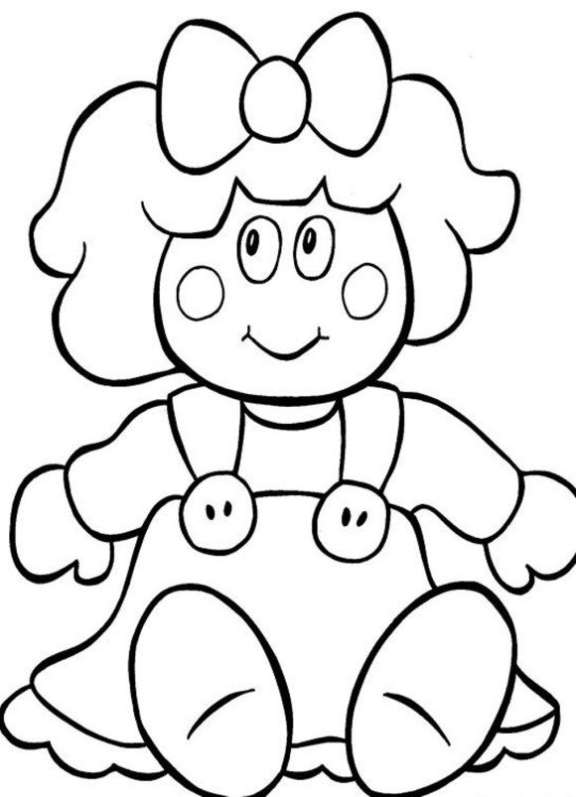

This is a doll.

This is a dog.

1.

This is a robot.

2.

This is a kite.

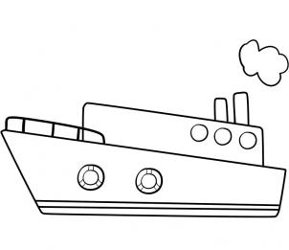

3. This is a ship.

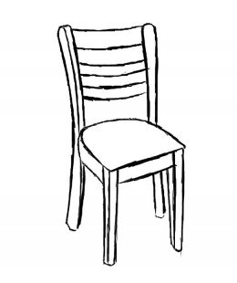

4.
This is a bed.

PART III: WRITING (2marks)
Question 1: Look at the pictures. Look at the letters. Write the words. (1mark)
Example:
r c h i a
chair

l p n a e

1. _ _ _ _ _
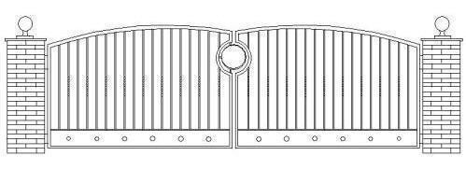

e g t a

2. _ _ _ _

3. _ _ _ _
a l b l

t b i b r a

4. _ _ _ _ _ _

Question 2: Order the words. (1mark)
Example:
weather/ What’s / the / like? => What’s the weather like?
1. they / What / are / doing ?
=> ?

2. park. / Quan and Nam / in / the / are
=> .

3. Đăk Lăk / What’s / the weather / in / like/ today?
=> ?

4. Do / teddy bear?/ you / a / have
=> ?
PART IV: SPEAKING (2marks) ( 5 minutes)
Part 1: Getting to know each other.
Part 2: Talking about a familiar object.
Part 3: Describing the picture.
-THE END-

ĐÁP ÁN ĐỀ KIỂM TRA HỌC KÌ II
MÔN TIẾNG ANH 3

I. LISTENING
Question 1. (track 71)
B.4 D.2 A.1 E.3
Question 2. (track 80)
1.D 2.C 3.B 4.E
Question 3. (track 63)
1.B 2.A 3.B 4.A
Question 4. (track 37)

1. robot 2.don’t 3.teddy 4.Yes.

II. READING

Question 1.

1.bed 2.under 3.parrots 4.garden
Question 2.
1. 2. 3. 4.

III. WRITING
Question 1.
1.plane 2.gate 3.ball 4.rabbit

×
Question 2.
1.What are they doing?
2.Nam and Quan are in the park.
3.What’s the weather like in Đăk Lăk today?
4.Do you have a teddy bear?
IV. SPEAKING

MA TRẬN ĐỀ THI TIẾNG ANH HỌC KỲ II LỚP 3 NĂM HỌC 2020-2021
Tên các nội dung, chủ đề, mạch kiến thức |  | Các mức độ nhận thức |  |  |  |  |  |  |  | Tổng  cộng
 |  | Mức 1  (Nhận biết) |  | Mức 2  (Thông hiểu) |  | Mức 3  (Vận dụng) |  | Mức 4  (Vận dụng nâng cao)
 |  | TN | TL | TN | TL | TN | TL | TN | TL
LISTENING  Toys,pets,  one’s action in progress, the weather | Câu số | Q1 (1,2,3,4)  Q3 (1,2,3,4) |  | Q2 (1,2,3,4) |  |  | Q4 (1,2,3,4)
 | Số điểm | 2 |  | 1 |  |  | 1 |  |  | 4
 | Số câu | 8 |  | 4 |  |  | 4 |  |  | 16
READING  Toys,pets,  one’s action in progress, the weather | Câu số | Q2 (1,2,3,4) |  |  | Q1 (1,2,3,4)
 | Số điểm | 1 |  |  | 1 |  |  |  |  | 2
 | Số câu | 4 |  |  | 4 |  |  |  |  | 8
WRITING  House facilities,  Toys,pets,  one’s action in progress, the weather | Câu số |  |  |  | Q1 (1,2,3,4) |  |  |  | Q2 (1,2,3,4)
 | Số điểm |  |  |  | 1 |  |  |  | 1 | 2
 | Số câu |  |  |  | 4 |  |  |  | 4 | 8
SPEAKING  Name,age,  Toys,pets,  one’s action in progress, the weather | Câu số |  |  | Q1 (1,2) |  | Q1 (1,2) |  |  | Q1 (1,2,3,4)
 | Số điểm |  |  | 0.5 |  | 0.5 |  |  | 1 | 2
 | Số câu |  |  | 2 |  | 2 |  |  | 4 | 8
Tổngsốcâu  Tổngsốđiểm  Tỉlệ % |  | 12  3  30% |  | 6  1.5  15% | 8  2  20% | 2  0.5  5% | 4  1  10% |  | 8  2  20% | 40  10.0  100%

Speaking
Part 1: Getting to know each other
The examiner asks these questions
- What’s your name?
- How old are you?
- Do you have a doll/kite/ship…?
- What pets do you have?
- What ’s the weather like today?
Part 2:Look and say.
1. What toys do you like?
2. How many planes/trucks… do you have?
3. What pets do you have?
4. How many dogs/parrots… do you have?
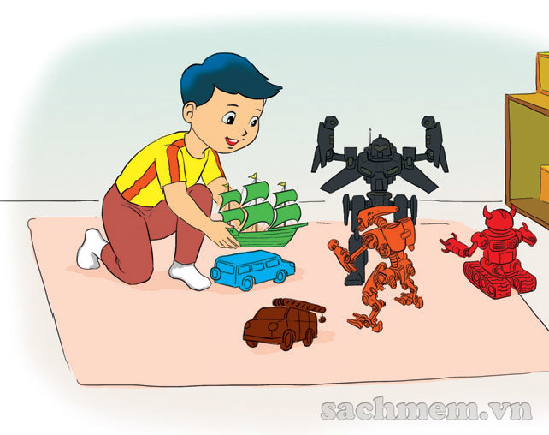
Part 3:Describing the pictures
Teacher says, “Now you have 30 seconds to look at these pictures.”
Teacher asks the questions.
1. What is he doing?
2. What is she doing?
3. What are they doing?
4. What’s the weather like?
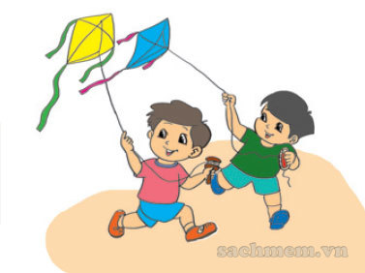

Đềcươngôntập.

I.Vocabulary
Puzzle/ ball/ robot/ yoyo/ sunny/ cloudy/ rainy/snowy/ park/ skip/ teddy bear/ kite/ have/ has/ cooking/ watch TV/ living room/ bedroom/ read/ draw a picture/ dog/ plane/ bed/ ship/ chair/ pond/ tree/ fence/ coat/ gate/ rabbit/ man/father/ mother/ map/ weather/ doll/ bird/ on/ in/goldfish/cat/parrot
II.Sentence patterns
1.Do you have a …?
2.Does he / she have …?
3.What are you doing?
4. What is he/she doing?
5. What are they doing?
6.What’s the weather like?
7.There is a ……………
8.Are there any…?
9.How old is your…?
10.Where are the…?
11.How many…?
12. Do you like ……

